SWE30010

HRM PROPOSAL FOR GEMADEPT

Name: Nguyen Dinh Nhat Minh  
ID: 103802490  
Tutor: Thomas Hang

**Project Proposal:** *Cloud-based work planner and organizer system*

## **1. Background / Problem Description**

Task management is critical in today’s world, from studying to working it is crucial that we keep track of our tasks, progress and development in order to manage our time and resources in the most efficient way possible. However, traditional methods of task tracking like paper based or standalone software introduces drawbacks that limits scalability and collaboration with other people; which is why our project proposed a cloud-based task planner and tracking system that would allow stream-lined management processes and enhanced collaboration within teams and organizations.

## **2. Scope**

**2.1 Objectives:**

The cloud-based planner app will assist in the steam-lining management process as it allows users to organize tasks, track progress, and manage deadlines effectively. This can be achieved as users can create, group and categorize projects based on their relativity or priority. The app will allow for collaboration between users which would facilitate increased collaboration and we aimed to have it working on both mobile and desktop which will aid in the overall productivity. Another notable objective we aimed for is deadline notification, which will notify users about tasks that are about to be due shortly.

**2.2 Solutions:**

To achieve the objectives listed, this software will include but not limited to these key features:

* **Task Organization:** Allow users to categorize and prioritize tasks via task groups, priority, or category, etc.
* **Collaboration:** Enable users to share tasks and projects with one another, assign tasks to team members, and track collaborative progress.
* **Progress Tracking:** Provide tools (checklists, progress bar, etc.) for users to track the progress of their tasks and projects, completion percentages, and milestone tracking.
* **Integration:** Integrate with other tools, plug-ins and platforms commonly used for productivity, like email, calendar apps, or communication tools like Slack.
* **Customization:** Offer customization options for users, which could include customizable task fields, color-coding options, or the ability to create custom task templates.
* **Mobile Accessibility:** The planner should be accessible on mobile devices via website or mobile app.
* **Notifications:** Provide customizable notification via email or in-app notifications settings to remind users of upcoming deadlines, task assignments, or changes to tasks.

## **3. Stakeholders**

| **Stakeholders** | **Interest** |
| --- | --- |
| Users | The primary stakeholders of the work organizer website are the users who will utilize the task management application. |
| Management | Higher-level management within the organization, who may provide oversight, guidance, support for the project or have strategic goals, objectives tied to the project's outcomes. |
| Project Team | The project team members, including developers, project managers, and quality assurance engineers, who are directly involved in the planning, development, and delivery of the website and have clear interest in creating the website. |

## **4. Deliverable and schedule**

**Schedule:**

This project is expected to take around 2 weeks (10 working days) to complete, while the maintenance support will be an on-going process. The timeline for each stage (from designing to implementation) of the project is outlined as follow:

* System Design and Prototyping: 1 day.
* Development and Testing: 7 days.
* Fine tuning and Implementation: 3 days.
* Post-implementation support and maintenance: On-going from go live date

**Initial Release Schedule of the Product backlog items**

| **No.** | **Item** | **Dependencies** | **Business Value (1 least – 10 most)** | **Release Schedule**  **(Sprint 1 | 2 | 3 | …)** |
| --- | --- | --- | --- | --- |
| F1 | Website design and wireframe. | None | 9 | Sprint 1 |
| F2 | Basic website with task card creation function. | None | 8 | Sprint 1 |
| F3 | Feature to hold tasks card defined. | F2 | 7 | Sprint 1 |
| F4 | Urgency assigned for tasks. | F3 | 7 | Sprint 1 |
| F5 | Signup and Login feature | F2 | 8 | Sprint 1 |
| F6 | Feature to set deadlines to tasks. | F2, F3 | 7 | Sprint 2 |
| F7 | Email users on impending deadline feature. | F3, F4 | 9 | Sprint 2 |
| F8 | Further customization options (background, color, ec.) | None | 5 | Sprint 2 |
| F9 | Feature to assign users to different tasks. | F2, F3, F5 | 8 | Sprint 2 |
| F10 | Integration with Google calendar. | F5, F9 | 7 | Sprint 3 |
| F11 | UAT Testing and suggestion collection. | After all prior product | 7 | Sprint 3 |
| F12 | Back and front-end thorough testing. | F11 | 8 | Sprint 3 |
| F13 | Final bug fix and documentation. | F12 | 9 | Sprint 4 |
| F14 | Go live and ongoing maintenance | F13 | 10 | Sprint 4 |

**Business value rationale:**

| **Sprint** | **Item** | **Business Value** | **Reasons** |
| --- | --- | --- | --- |
| Sprint 1 | Website design and wireframe. | 9 | Essential for setting the overall tone and impression of the website. |
| Sprint 1 | Basic website with task card creation function. | 8 | Forms the backbone of the website's core functionality. |
| Sprint 1 | Feature to hold tasks card defined. | 7 | Fundamental to the website's purpose and usability. But is less significant as it is a feature, not backbone. |
| Sprint 1 | Urgency assigned for tasks. | 7 | Enhances efficiency in task management and prioritization. But is less significant compared to other items in the sprint. |
| Sprint 1 | Signup and Login feature | 8 | Essential for user authentication and engagement. |
| Sprint 2 | Feature to set deadlines to tasks. | 7 | Promotes time management and productivity. But is less significant as it is a feature, not backbone. |
| Sprint 2 | Email users on impending deadline feature. | 9 | Significantly enhances user engagement and task completion. |
| Sprint 2 | Further customization options (background, color, ec.) | 5 | While adds value in user satisfaction, not critical to core functionality. |
| Sprint 2 | Feature to assign users to different tasks. | 8 | Facilitates collaboration and delegation, essential for team-based projects. Foster collaboration, one of the key (but not the most important) feature |
| Sprint 3 | Integration with Google calendar. | 7 | Synchronizes tasks and deadlines with a widely used calendar platform. But is less significant compared to other items in the sprint |
| Sprint 3 | UAT Testing and suggestion collection. | 7 | Ensures functionality and usability meet user expectations. Significant, but need completion from other features in the sprint. |
| Sprint 3 | Back and front-end thorough testing. | 8 | Crucial for reliability, performance, and user experience. |
| Sprint 4 | Final bug fix and documentation. | 9 | Ensures stability, maintainability, and smooth transition to a live environment. |
| Sprint 4 | Go live and ongoing maintenance | 10 | Critical for launching a website and ensuring continued operation and improvement. |

**Work Breakdown Structure:**

We will use the Work Breakdown structure to estimate the effort it will take to develop our first sprint of the project. As we have 2 weeks to complete the project, and each person will work at most 8 hours per week which leaves us with 64 hours to plan our project.

As the first sprint has the most number of products with a great degree of complexity, half of the effort will be put into developing this sprint. This is because the subsequent sprint relies on this sprint as the backbone, hence, its completeness is the utmost priority. So 34 hours will be put into the first sprint, while the remaining 30 hours will be spread between the other 3.

**Sprint 1**

1. **Product F1**

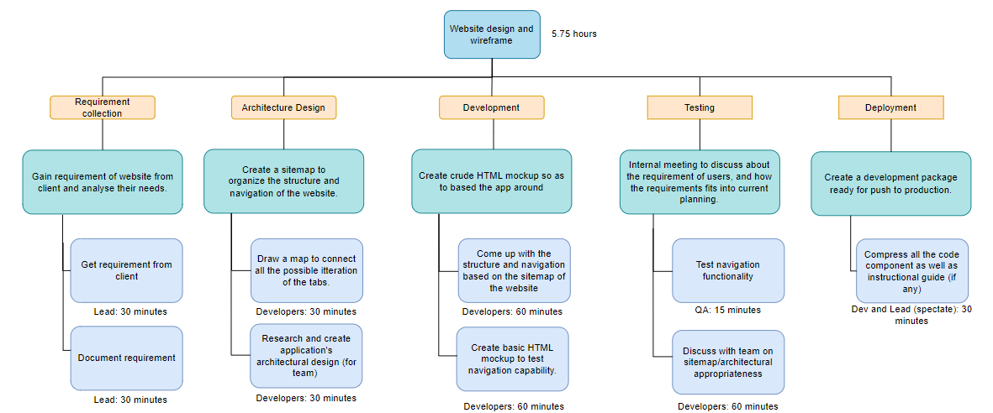

1. **Product F2**

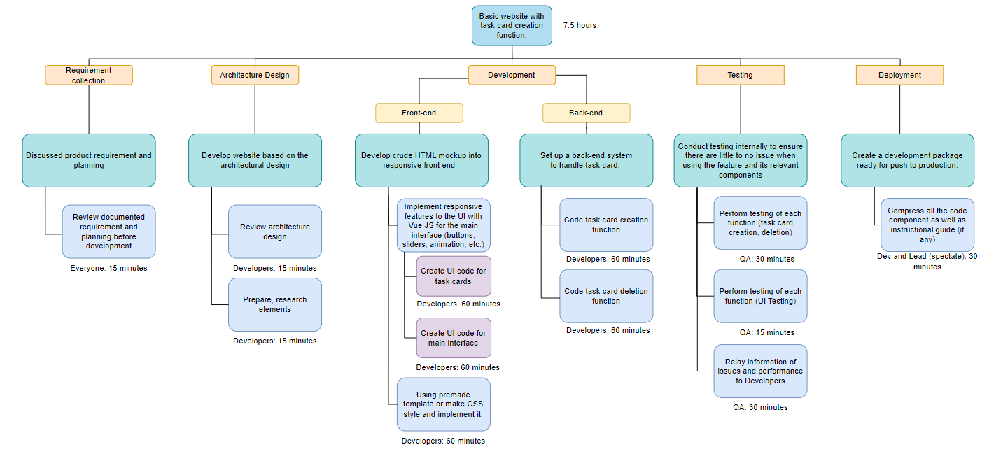

1. **Product F3**

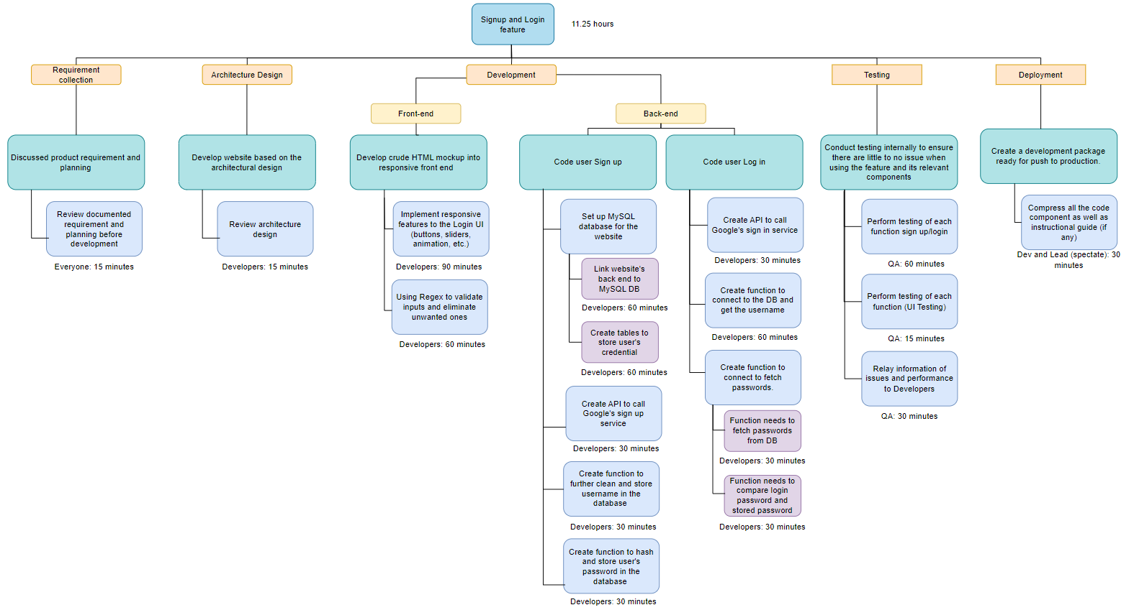

1. **Product F4**

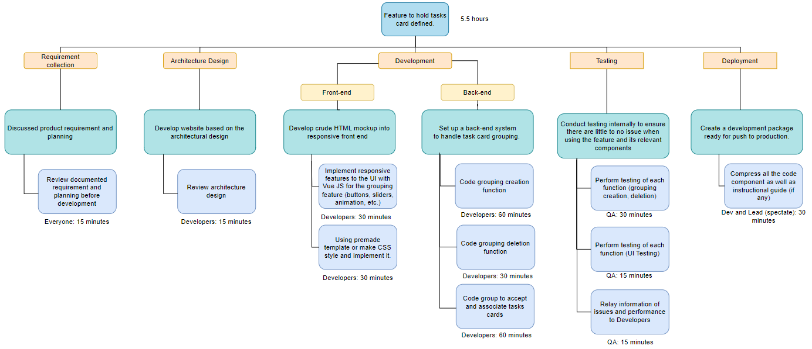

1. **Product F5**

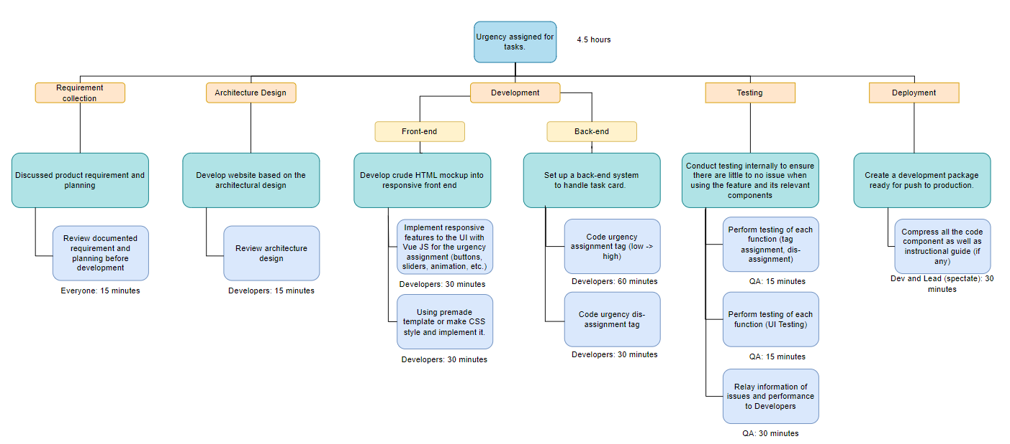

## **5. Solution Direction**

**Architecture**

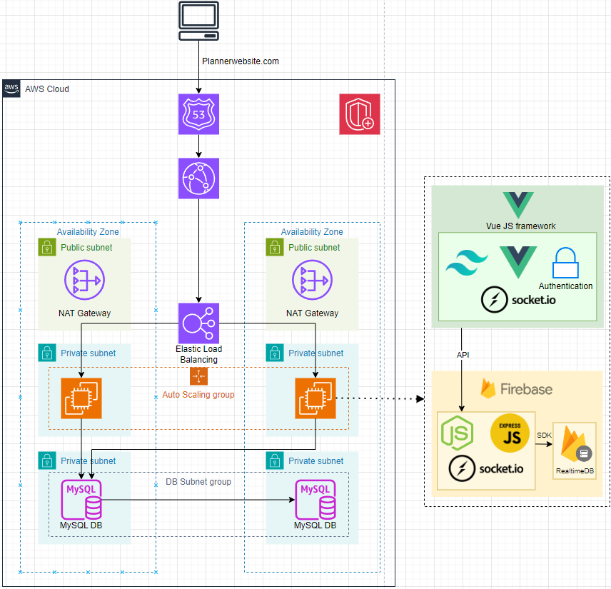

## **6. Quality management**

**DEFINITION OF DONE CHECKLIST**

The following checklist is prepared based on the ISO25010 Model with 8 main characteristics to measure the ‘Quality’ of the HRM application.

| **No** | **(Sub) Characteristics** | **Description** | **Y/N** |
| --- | --- | --- | --- |
| **1. Functionality Suitability** | | | |
| 1.1 | Functional Appropriateness | Deploy the website on AWS | ☐ |
| 1.2 | Functional Appropriateness | The platform allows users to switch between different languages. All content, messages, and alternative text are translated correctly | ☐ |
| 1.3 | Functional Appropriateness | The platform's core functionalities can integrate with external systems, such as Google calendar, other planners. | ☐ |
| 1.4 | Functional Correctness | During the account registration process, important fields such as name, password, and email are required | ☐ |
| 1.5 | Functional Correctness | Every tasks or group created by the users must appear correctly | ☐ |
| 1.6 | Functional Correctness | The searching and filtering options return the correct result | ☐ |
| 1.7 | Functional Completeness | The app can display well-organized progress reports, and information of the users. | ☐ |
| 1.8 | Functional Completeness | The platform can send notifications via email to remind users to complete impending tasks. | ☐ |
| **2. Performance Efficiency** | | | |
| 2.1 | Time Behaviour | The following actions have a response time of less than 2 seconds:  § Return searching results after users search the tasks created or functions of the app.  § Display all tasks made by users.  § Display the user data when clicking on the user’s profile.  § Create or delete task cards.  § Login/Logout | ☐ |
| 2.2 | Time Behaviour | The loading time of pages is less than 5 seconds | ☐ |
| 2.3 | Resource Utilization | The CPU utilization when running the platform is below 80% and memory consumption is below 70% | ☐ |
| 2.4 | Capacity | A simulated workload of 1,000 users is used for testing. Could the platform handle this simulated workload without reducing the performance by at least 30% | ☐ |
| **3. Compatibility** | | | |
| 3.1 | Co-existence | The platform can operate simultaneously with at least 2 other software in an operating system without conflicting | ☐ |
| 3.2 | Interoperability | 95% of record (reports, deadlines) shows up correctly on third-party system | ☐ |
| 3.3 | Interoperability | The operational data of the platform can be displayed on the data analytics tool in real-time with a maximum delay of 1 minute. | ☐ |
| **4. Usability** | | | |
| 4.1 | Appropriate recognizability | Users complete the following tasks in less than 3 minutes:  § Register a new account.  § Create tasks, assign deadlines. | ☐ |
| 4.2 | Learnability | 90% of users can complete basic tasks to serve their needs on the first day of the testing period | ☐ |
| 4.3 | Operability | The average number of errors that test users encountered during a 15- minute testing session is less than 2 errors | ☐ |
| 4.4 | User interface aesthetics | The platform is responsive on desktop, and mobile | ☐ |
| 4.5 | User interface aesthetics | This condition is evaluated based on feedback survey  The minimum average satisfaction score of 20 users about the UX/UI of the platform, including webpage structure, text font, color palette, languages, navigation, information display, buttons, etc. is 8 out of 10 | ☐ |
| 4.6 | User error protection | 90% of test users can understand the content of the confirmation dialog box displayed when they:  · Create tasks, create groups.  · Update their information.  · Change the customization settings. | ☐ |
| 4.7 | Accessibility | 80% of non-text content (video, images) have alternative text descriptions | ☐ |
| **5. Reliability** | | | |
| 5.1 | Maturity | Mean Time Between Failures (MTBF) metrics of the platform is at least 30 days | ☐ |
| 5.2 | Fault Tolerance | Mean Time to Recover (MTTR) takes less than 2 hours to recover platform data from errors or failures | ☐ |
| 5.3 | Recoverability | All functionalities of the platform can be fully restored from the backup within 5 hours after the failure | ☐ |
| 5.4 | Availability | The platform is accessible for 99.9% of operating hours | ☐ |
| **6. Security** | | | |
| 6.1 | Confidentiality | Block at least 95% of unauthorized access attempts and send alerts to users | ☐ |
| 6.2 | Confidentiality | Data encryption and secure authentication protocols are integrated | ☐ |
| 6.3 | Integrity | 100% of data is stored and transmitted correctly. Data in the databases is reflected correctly on the user interface and data analytics tools | ☐ |
| 6.4 | Integrity | The platform follows data protection regulations | ☐ |
| 6.5 | Non-repudiation | Implement non-repudiation measures for at least 95% of user actions | ☐ |
| 6.6 | Accountability | 100% of user interactions on the platform and the platform events are recorded in the logbook | ☐ |
| 6.7 | Authenticity | 95% of user authentication processes are successful | ☐ |
| **7. Maintainability** | | | |
| 7.1 | Analyzability | Reduce time taken to diagnose and resolve reported issues to less than 1 hour 30 minutes | ☐ |
| 7.2 | Modifiability | New change/enhancement is integrated into the platform 1 week after the change request is made | ☐ |
| 7.3 | Testability | Maintain a code coverage of at least 80% through automated test cases | ☐ |
| 7.4 | Modularity | The platform architecture is designed with at least 5 modules | ☐ |
| 7.5 | Reusability | All codes have naming conventions, and comments to modify when needed without affecting other parts (Low coupling – High cohesion) | ☐ |
| 7.6 | Reusability | A minimum of 80% code is reusable | ☐ |
| **8. Portability** | | | |
| 8.1 | Adaptability | The time to deploy the platform on a new hosting server (on-premises or cloud server) is less than 7 days | ☐ |
| 8.2 | Installability | The time to complete the installation and configuration of all platform components in an environment is less than 8 hours | ☐ |
| 8.3 | Replaceability | Could we replace a component of the platform with a migration time of less than 1 week without impact on other components? | ☐ |

## **7. Approval Signatures**

**a. Project Team**

| **No.** | **Name** | **Role** | **ID** | **Signature** |
| --- | --- | --- | --- | --- |
| 1 | Nguyen Dinh Nhat Minh | Project Manager | 103802490 |  |
| 2 | Personnel 2 | Developer | 2 |  |
| 3 | Personnel 3 | Developer | 3 |  |
| 4 | Personnel 4 | Quality Assurance | 4 |  |

**b. Project Sponsor [Your Tutor]**

| **Tutor** | **Signature** |
| --- | --- |
| Thomas Hang |  |